« If we want a new kind of game then let's do it »

Bucc Games

-Bucc D.

New games of Bucc Games

Bucc-Games, a small independent game development studio, has recently released their latest title "Brave the Backrooms" on the Unreal Engine. The game has been a great success, with many players and critics praising its unique gameplay mechanics and immersive atmosphere.
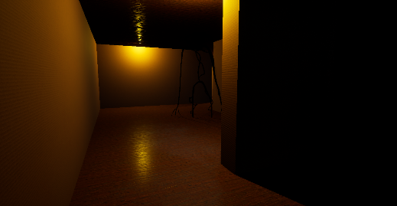
"Brave the Backrooms" is a first-person survival horror game that takes place in a mysterious labyrinthine structure known as the "backrooms". Players must navigate through the maze-like corridors while avoiding dangerous entities that lurk within. The game's mechanics focus on resource management and stealth, forcing players to carefully conserve their limited resources while avoiding detection. The creators of "Brave the Backrooms" had to work with great precision to create such a frightening atmosphere. We are convinced that even the monsters took yoga classes to stand properly in the narrow corridors of the Backrooms
Despite being a relatively small studio, Bucc-Games has managed to create a game that rivals those of much larger developers. The attention to detail in the game's environment and creature designs is impressive, and the sound design is particularly noteworthy, creating an eerie and unsettling atmosphere that perfectly complements the game's theme. The creators of Bucc-Games worked so hard to create "Brave the Backrooms" that they decided to take a vacation... in the Backrooms! (But we do not recommend this destination for a relaxing vacation.)
The game's success is a testament to the passion and dedication of the team at Bucc-Games. They have managed to create a truly unique and engaging game that stands out in a crowded market. The positive reception from players and critics alike is well-deserved, and we look forward to seeing what Bucc-Games has in store for us in the future.
The Unreal Engine is a game engine developed by Epic Games. It is used to create video games and other interactive applications. The Unreal Engine has been used to create many popular games such as Fortnite, Gears of War, and Rocket League.
The game engine is designed to facilitate the creation of video games by providing tools for level design, character and object modeling, animation, programming, and physics management. The Unreal Engine is also known for its ability to create high-quality graphics and visual effects, making it a popular choice for game developers.
As for the Backrooms, it is an internet urban legend that began circulating on forums and websites in the late 2000s. According to the legend, the Backrooms are a network of endless rooms and corridors that exist between the walls and floors of buildings. It is said that if someone enters the Backrooms, they will be trapped in a monotonous and endless environment where the lights are fluorescent and constantly flickering.

Bucc-Games is a company specializing in video game development. Founded two years ago, it has experienced rapid growth and has quickly gained a reputation for creating innovative and high-quality games. The company recently released its latest game, "Brave the Backrooms," which has been very successful with both gamers and critics.
Bucc-Games currently has a revenue of €200,000, demonstrating its growing popularity in the video game industry. This success has been made possible by a team of talented and passionate developers who work tirelessly to produce unique and engaging games.
Bucc-Games plans to continue innovating and creating exceptional games in the years to come, building on its experience and expertise in video game development. The company also aims to develop partnerships with other industry players to expand its reach and increase its presence in the market.

